^{DESIGN OF DIGITAL SYSTEMS LAB}
^{PHONE} ^{BILLING SYSTEM}
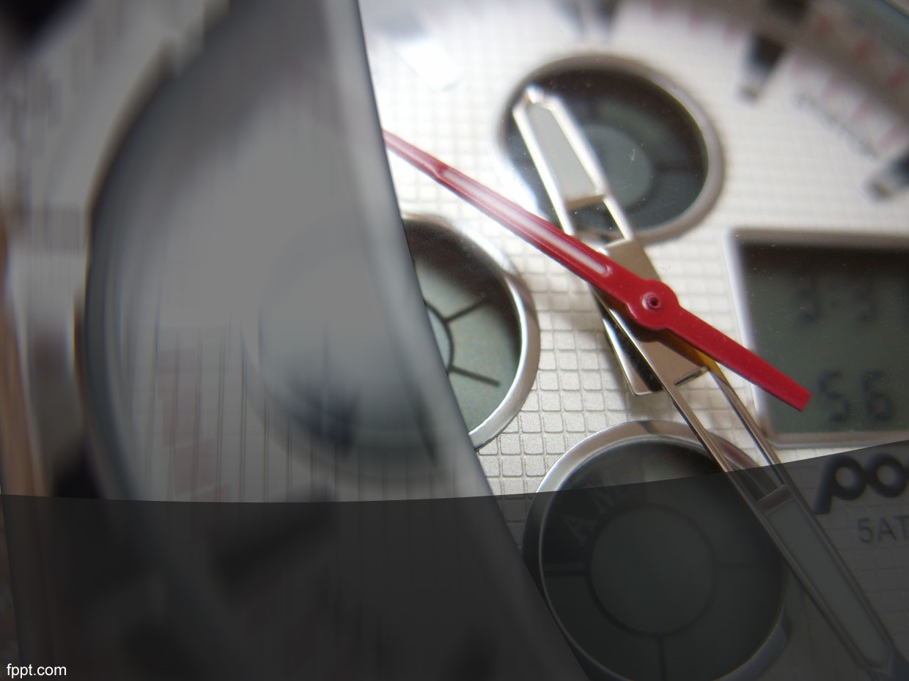
SUBMITTED TO:
SHILPA K.V madam
SUBMITTED BY
VRUSHAB MAITRI-13CO253
SAI SATHVIK.S -13CO138
OBJECTIVE
•TO SIMULATE A DIGITAL MODEL OF PHONE BILLING SYSTEM.
OVERVIEW

THE CIRCUIT AIMS AT COMPUTING CALL DURATION AND CORRESPONDING AMOUNT.THE AMOUNT IS CALCULATED BASED ON PRESET CALL RATE.

COMPONENTS REQUIRED

•BASIC GATES:
TO IMPLEMENT THE BASIC LOGICAL OPERATIONS ALONG WITH COUNTERS
•D FLIP FLOPS:
TO DESIGN COUNTERS.
• SEVEN-SEGMENT DISPLAY:
USED FOR DISPLAYING PRICE AND CALL DURATION
WORKING:
THE LOGIC BEHIND THE DESIGN IS,WHEN THE CALL BEGINS,BOTH THE TIMER AND BILL CALCULATING CIRCUITS ARE TRIGGERED SIMULTANEOUSLY BY A MASTER CLOCK. THESE CIRCUITS ARE BASICALLY COUNTERS.THEY ARE CONNECTED TO A SEVEN-SEGMENT DISPLAY. ONCE THE CALL IS TERMINATED THE TOTAL CALL DURATION AND PRICE WILL BE DISPLAYED IN SEVEN-SEGMENT FORMAT.

IMPLEMENTATION:
THE TIMER CIRCUIT IS DESIGNED USING COUNTERS,WHICH ARE BASICALLY MOD-9 AND MOD-6 COUNTERS.COUNTERS ARE IMPLEMENTED USING D-FLIP FLOPS.
IN A SIMILAR WAY A BILLING MODULE IS DESIGNED USING COUNTERS,WHICH WORKS IN SYNC WITH TIMER AND PREFIXED CALL-RATE.
THE APPROPRIATE COUNTER OUTPUTS ARE CONNECTED TO SEVEN-SEGMENT DISPLAY,THUS SHOWING THE DURATION AND PRICE

MOD-6:
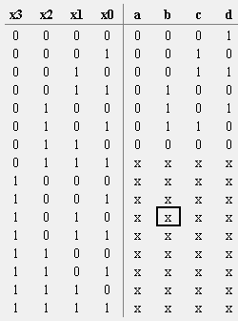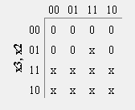
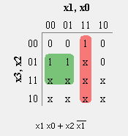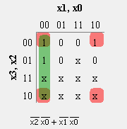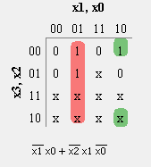

MOD-9:
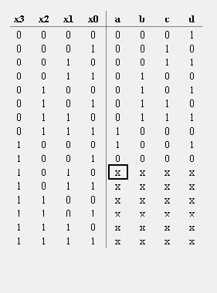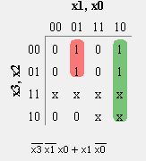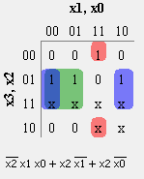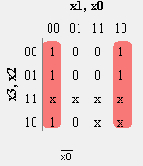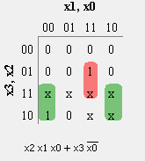

SEVEN SEGMENT DISPLAY:
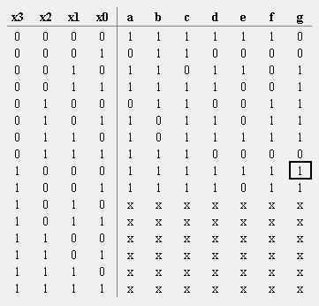
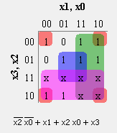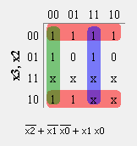
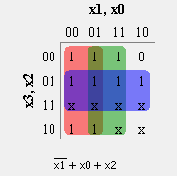
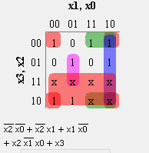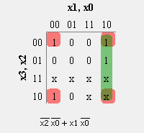
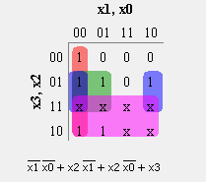
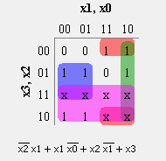

CIRCUIT DIAGRAMS
MOD 6 COUNTER
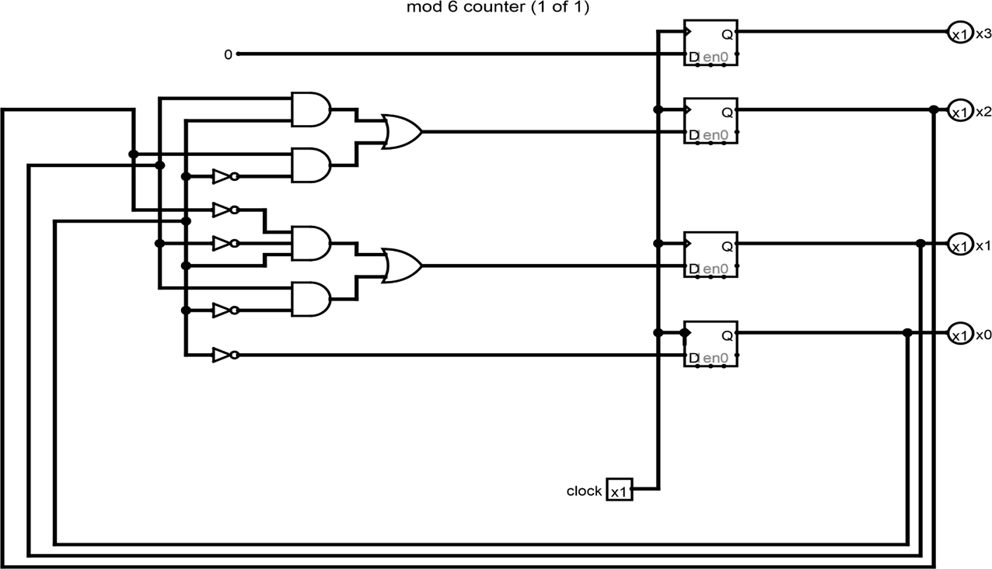

MOD 9 COUNTER

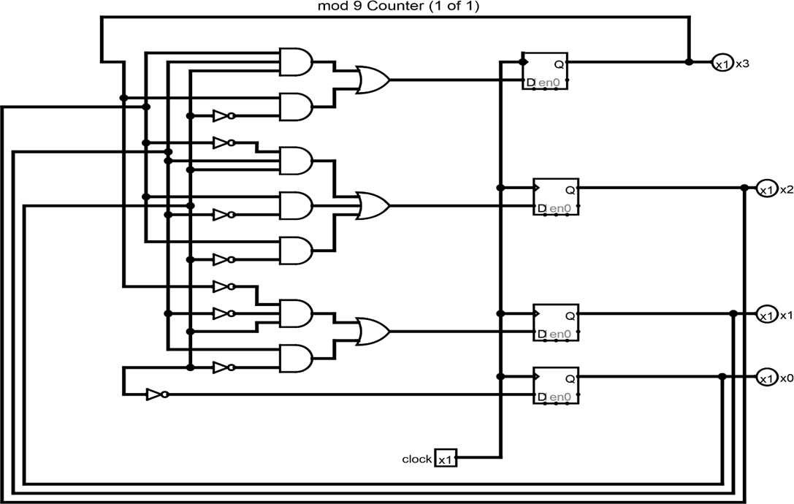

BILL CONTROL
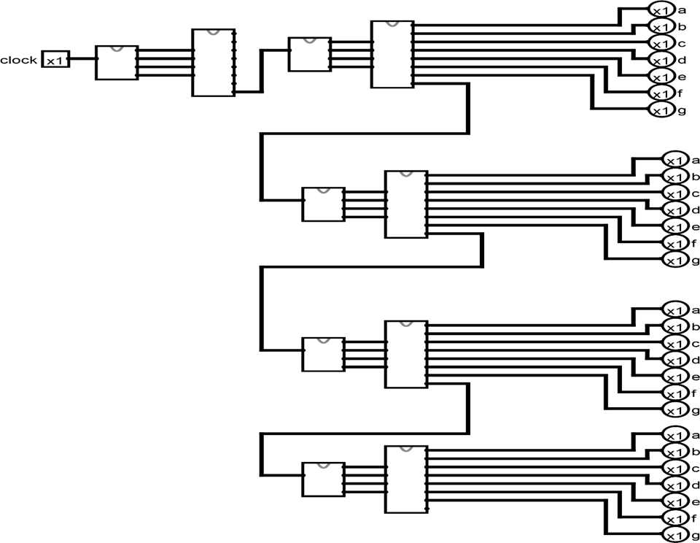

TIMER CIRCUIT

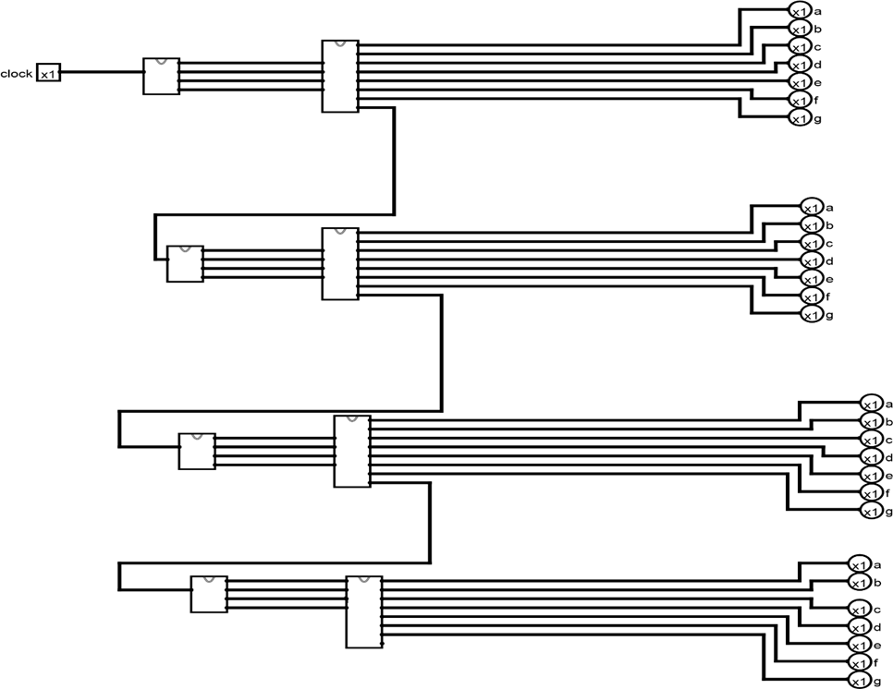

SEVEN SEGMENT DISPLAY
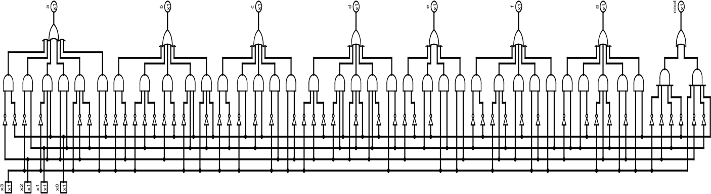

DEMERITS:
IN THE PRESENT DESIGN,THERE IS NO FLEXIBILITY AS THE CALL-RATE IS A FIXED ENTITY.IF IT HAS TO BE MODIFIED SOME CIRCUIT-LEVEL CHANGES HAVE TO BE INCORPORATED.

APPLICATIONS:
ONE OF THE MAJOR APPLICATION IS IN PHONE BOOTHS,WHERE TRACK OF CALL DURATION AND COST IS MAINTAINED.
CONCLUSION:
THE DIGITAL SIMULATION OF PHONE-BILLING SYSTEM HAS BEEN IMPLEMENTED.

